évaluation Entretenir le logement

Et le linge d’un particulier

**Nom, Prénom du stagiaire :**

**Intitulé de la formation : CCP1 Entretenir le logement**



Déroulement :

Vous avez 5 heures pour réaliser votre évaluation

Il n’y aura pas de pause pendant l’évaluation

Il est important de bien lire les consignes

|  |
| --- |
| **APPRÉCIATION DU FORMATEUR :** |
| * _ _ _ _ _ _ _ _ _ _ _ _ _ _ _ _ _ _ _ _ _ _ _ _ _ _ _ _ _ _ _ _ _ _ _ _ _ _ _ _ _ _ _ _ _ _ _ _ _ _ _ _ _ _ _ _ _ _ _ _ _ * _ _ _ _ _ _ _ _ _ _ _ _ _ _ _ _ _ _ _ _ _ _ _ _ _ _ _ _ _ _ _ _ _ _ _ _ _ _ _ _ _ _ _ _ _ _ _ _ _ _ _ _ _ _ _ _ _ _ _ _ _ * _ _ _ _ _ _ _ _ _ _ _ _ _ _ _ _ _ _ _ _ _ _ _ _ _ _ _ _ _ _ _ _ _ _ _ _ _ _ _ _ _ _ _ _ _ _ _ _ _ _ _ _ _ _ _ _ _ _ _ _ _ * _ _ _ _ _ _ _ _ _ _ _ _ _ _ _ _ _ _ _ _ _ _ _ _ _ _ _ _ _ _ _ _ _ _ _ _ _ _ _ _ _ _ _ _ _ _ _ _ _ _ _ _ _ _ _ _ _ _ _ _ _ * _ _ _ _ _ _ _ _ _ _ _ _ _ _ _ _ _ _ _ _ _ _ _ _ _ _ _ _ _ _ _ _ _ _ _ _ _ _ _ _ _ _ _ _ _ _ _ _ _ _ _ _ _ _ _ _ _ _ _ _ _ |

**Quelle est l’importance d’entretenir le logement ou le lieu de vie de la personne aidée ?**

* _ _ _ _ _ _ _ _ _ _ _ _ _ _ _ _ _ _ _ _ _ _ _ _ _ _ _ _ _ _ _ _ _ _ _ _ _ _ _ _ _ _ _ _ _ _ _ _ _ _ _ _ _ _ _ _ _ _ _
* _ _ _ _ _ _ _ _ _ _ _ _ _ _ _ _ _ _ _ _ _ _ _ _ _ _ _ _ _ _ _ _ _ _ _ _ _ _ _ _ _ _ _ _ _ _ _ _ _ _ _ _ _ _ _ _ _ _ _
* _ _ _ _ _ _ _ _ _ _ _ _ _ _ _ _ _ _ _ _ _ _ _ _ _ _ _ _ _ _ _ _ _ _ _ _ _ _ _ _ _ _ _ _ _ _ _ _ _ _ _ _ _ _ _ _ _ _ _
* _ _ _ _ _ _ _ _ _ _ _ _ _ _ _ _ _ _ _ _ _ _ _ _ _ _ _ _ _ _ _ _ _ _ _ _ _ _ _ _ _ _ _ _ _ _ _ _ _ _ _ _ _ _ _ _ _ _ _
* _ _ _ _ _ _ _ _ _ _ _ _ _ _ _ _ _ _ _ _ _ _ _ _ _ _ _ _ _ _ _ _ _ _ _ _ _ _ _ _ _ _ _ _ _ _ _ _ _ _ _ _ _ _ _ _ _ _ _
* _ _ _ _ _ _ _ _ _ _ _ _ _ _ _ _ _ _ _ _ _ _ _ _ _ _ _ _ _ _ _ _ _ _ _ _ _ _ _ _ _ _ _ _ _ _ _ _ _ _ _ _ _ _ _ _ _ _ _

**Quelle est la particularité de l’utilisation d’une microfibre au lieu d’un chiffon normal ?**

* _ _ _ _ _ _ _ _ _ _ _ _ _ _ _ _ _ _ _ _ _ _ _ _ _ _ _ _ _ _ _ _ _ _ _ _ _ _ _ _ _ _ _ _ _ _ _ _ _ _ _ _ _ _ _ _ _ _ _
* _ _ _ _ _ _ _ _ _ _ _ _ _ _ _ _ _ _ _ _ _ _ _ _ _ _ _ _ _ _ _ _ _ _ _ _ _ _ _ _ _ _ _ _ _ _ _ _ _ _ _ _ _ _ _ _ _ _ _
* _ _ _ _ _ _ _ _ _ _ _ _ _ _ _ _ _ _ _ _ _ _ _ _ _ _ _ _ _ _ _ _ _ _ _ _ _ _ _ _ _ _ _ _ _ _ _ _ _ _ _ _ _ _ _ _ _ _ _
* _ _ _ _ _ _ _ _ _ _ _ _ _ _ _ _ _ _ _ _ _ _ _ _ _ _ _ _ _ _ _ _ _ _ _ _ _ _ _ _ _ _ _ _ _ _ _ _ _ _ _ _ _ _ _ _ _ _ _
* _ _ _ _ _ _ _ _ _ _ _ _ _ _ _ _ _ _ _ _ _ _ _ _ _ _ _ _ _ _ _ _ _ _ _ _ _ _ _ _ _ _ _ _ _ _ _ _ _ _ _ _ _ _ _ _ _ _ _
* _ _ _ _ _ _ _ _ _ _ _ _ _ _ _ _ _ _ _ _ _ _ _ _ _ _ _ _ _ _ _ _ _ _ _ _ _ _ _ _ _ _ _ _ _ _ _ _ _ _ _ _ _ _ _ _ _ _ _

**Quelle est votre organisation dans l’entretien du logement, par quoi allez-vous commencer ?**

* _ _ _ _ _ _ _ _ _ _ _ _ _ _ _ _ _ _ _ _ _ _ _ _ _ _ _ _ _ _ _ _ _ _ _ _ _ _ _ _ _ _ _ _ _ _ _ _ _ _ _ _ _ _ _ _ _ _ _
* _ _ _ _ _ _ _ _ _ _ _ _ _ _ _ _ _ _ _ _ _ _ _ _ _ _ _ _ _ _ _ _ _ _ _ _ _ _ _ _ _ _ _ _ _ _ _ _ _ _ _ _ _ _ _ _ _ _ _
* _ _ _ _ _ _ _ _ _ _ _ _ _ _ _ _ _ _ _ _ _ _ _ _ _ _ _ _ _ _ _ _ _ _ _ _ _ _ _ _ _ _ _ _ _ _ _ _ _ _ _ _ _ _ _ _ _ _ _
* _ _ _ _ _ _ _ _ _ _ _ _ _ _ _ _ _ _ _ _ _ _ _ _ _ _ _ _ _ _ _ _ _ _ _ _ _ _ _ _ _ _ _ _ _ _ _ _ _ _ _ _ _ _ _ _ _ _ _
* _ _ _ _ _ _ _ _ _ _ _ _ _ _ _ _ _ _ _ _ _ _ _ _ _ _ _ _ _ _ _ _ _ _ _ _ _ _ _ _ _ _ _ _ _ _ _ _ _ _ _ _ _ _ _ _ _ _ _
* _ _ _ _ _ _ _ _ _ _ _ _ _ _ _ _ _ _ _ _ _ _ _ _ _ _ _ _ _ _ _ _ _ _ _ _ _ _ _ _ _ _ _ _ _ _ _ _ _ _ _ _ _ _ _ _ _ _ _
* _ _ _ _ _ _ _ _ _ _ _ _ _ _ _ _ _ _ _ _ _ _ _ _ _ _ _ _ _ _ _ _ _ _ _ _ _ _ _ _ _ _ _ _ _ _ _ _ _ _ _ _ _ _ _ _ _ _ _
* _ _ _ _ _ _ _ _ _ _ _ _ _ _ _ _ _ _ _ _ _ _ _ _ _ _ _ _ _ _ _ _ _ _ _ _ _ _ _ _ _ _ _ _ _ _ _ _ _ _ _ _ _ _ _ _ _ _ _
* _ _ _ _ _ _ _ _ _ _ _ _ _ _ _ _ _ _ _ _ _ _ _ _ _ _ _ _ _ _ _ _ _ _ _ _ _ _ _ _ _ _ _ _ _ _ _ _ _ _ _ _ _ _ _ _ _ _ _
* _ _ _ _ _ _ _ _ _ _ _ _ _ _ _ _ _ _ _ _ _ _ _ _ _ _ _ _ _ _ _ _ _ _ _ _ _ _ _ _ _ _ _ _ _ _ _ _ _ _ _ _ _ _ _ _ _ _ _
* _ _ _ _ _ _ _ _ _ _ _ _ _ _ _ _ _ _ _ _ _ _ _ _ _ _ _ _ _ _ _ _ _ _ _ _ _ _ _ _ _ _ _ _ _ _ _ _ _ _ _ _ _ _ _ _ _ _ _
* _ _ _ _ _ _ _ _ _ _ _ _ _ _ _ _ _ _ _ _ _ _ _ _ _ _ _ _ _ _ _ _ _ _ _ _ _ _ _ _ _ _ _ _ _ _ _ _ _ _ _ _ _ _ _ _ _ _ _

**Une surface plane, une table, une vitre, un cadre, une porte, comment allez-vous nettoyer ?**

* _ _ _ _ _ _ _ _ _ _ _ _ _ _ _ _ _ _ _ _ _ _ _ _ _ _ _ _ _ _ _ _ _ _ _ _ _ _ _ _ _ _ _ _ _ _ _ _ _ _ _ _ _ _ _ _ _ _ _
* _ _ _ _ _ _ _ _ _ _ _ _ _ _ _ _ _ _ _ _ _ _ _ _ _ _ _ _ _ _ _ _ _ _ _ _ _ _ _ _ _ _ _ _ _ _ _ _ _ _ _ _ _ _ _ _ _ _ _
* _ _ _ _ _ _ _ _ _ _ _ _ _ _ _ _ _ _ _ _ _ _ _ _ _ _ _ _ _ _ _ _ _ _ _ _ _ _ _ _ _ _ _ _ _ _ _ _ _ _ _ _ _ _ _ _ _ _ _
* _ _ _ _ _ _ _ _ _ _ _ _ _ _ _ _ _ _ _ _ _ _ _ _ _ _ _ _ _ _ _ _ _ _ _ _ _ _ _ _ _ _ _ _ _ _ _ _ _ _ _ _ _ _ _ _ _ _ _
* _ _ _ _ _ _ _ _ _ _ _ _ _ _ _ _ _ _ _ _ _ _ _ _ _ _ _ _ _ _ _ _ _ _ _ _ _ _ _ _ _ _ _ _ _ _ _ _ _ _ _ _ _ _ _ _ _ _ _
* _ _ _ _ _ _ _ _ _ _ _ _ _ _ _ _ _ _ _ _ _ _ _ _ _ _ _ _ _ _ _ _ _ _ _ _ _ _ _ _ _ _ _ _ _ _ _ _ _ _ _ _ _ _ _ _ _ _ _

**Expliquez l’entretien de cette table, comment la nettoyez-vous. Schématiser sur le dessin.**

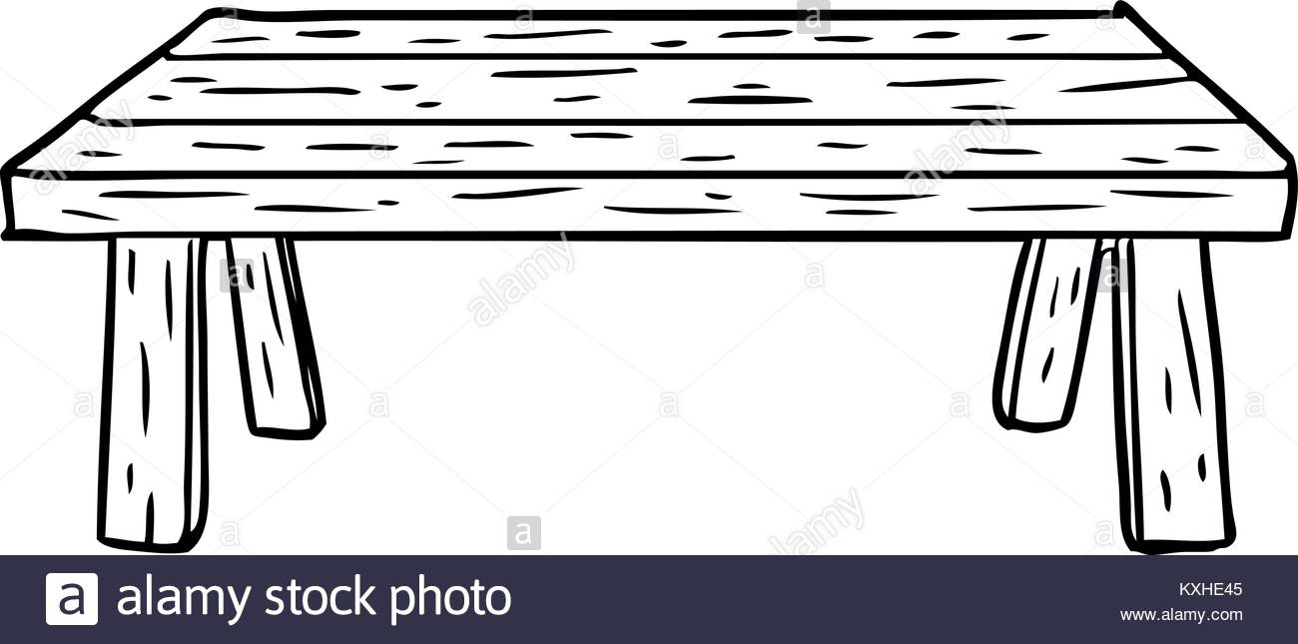

* _ _ _ _ _ _ _ _ _ _ _ _ _ _ _ _ _ _ _ _ _ _ _ _ _ _ _ _ _ _ _ _ _ _ _ _ _ _ _ _ _ _ _ _ _ _ _ _ _ _ _ _ _ _ _ _ _ _ _
* _ _ _ _ _ _ _ _ _ _ _ _ _ _ _ _ _ _ _ _ _ _ _ _ _ _ _ _ _ _ _ _ _ _ _ _ _ _ _ _ _ _ _ _ _ _ _ _ _ _ _ _ _ _ _ _ _ _ _
* _ _ _ _ _ _ _ _ _ _ _ _ _ _ _ _ _ _ _ _ _ _ _ _ _ _ _ _ _ _ _ _ _ _ _ _ _ _ _ _ _ _ _ _ _ _ _ _ _ _ _ _ _ _ _ _ _ _ _
* _ _ _ _ _ _ _ _ _ _ _ _ _ _ _ _ _ _ _ _ _ _ _ _ _ _ _ _ _ _ _ _ _ _ _ _ _ _ _ _ _ _ _ _ _ _ _ _ _ _ _ _ _ _ _ _ _ _ _
* _ _ _ _ _ _ _ _ _ _ _ _ _ _ _ _ _ _ _ _ _ _ _ _ _ _ _ _ _ _ _ _ _ _ _ _ _ _ _ _ _ _ _ _ _ _ _ _ _ _ _ _ _ _ _ _ _ _ _

**Décrivez-moi les étapes :**

**Expliquez l’entretien de ce miroir, comment le nettoyez-vous. Schématiser sur le dessin.**

**Décrivez-moi les étapes :**

* _ _ _ _ _ _ _ _ _ _ _ _ _ _ _ _ _ _ _ _ _ _ _ _ _ _ _ _ _ _ _ _ _ _ _ _ _ _
* _ _ _ _ _ _ _ _ _ _ _ _ _ _ _ _ _ _ _ _ _ _ _ _ _ _ _ _ _ _ _ _ _ _ _ _ _ _
* _ _ _ _ _ _ _ _ _ _ _ _ _ _ _ _ _ _ _ _ _ _ _ _ _ _ _ _ _ _ _ _ _ _ _ _ _ _
* _ _ _ _ _ _ _ _ _ _ _ _ _ _ _ _ _ _ _ _ _ _ _ _ _ _ _ _ _ _ _ _ _ _ _ _ _ _
* _ _ _ _ _ _ _ _ _ _ _ _ _ _ _ _ _ _ _ _ _ _ _ _ _ _ _ _ _ _ _ _ _ _ _ _ _ _
* _ _ _ _ _ _ _ _ _ _ _ _ _ _ _ _ _ _ _ _ _ _ _ _ _ _ _ _ _ _ _ _ _ _ _ _ _ _

**Expliquez l’entretien de ce lavabo, comment le nettoyez-vous. Schématiser sur le dessin.**

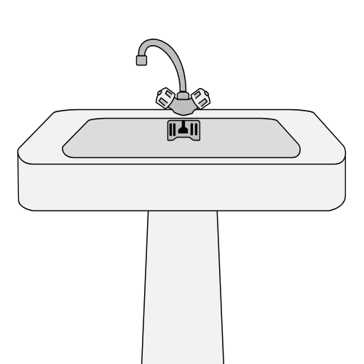**Décrivez-moi les étapes :**

* _ _ _ _ _ _ _ _ _ _ _ _ _ _ _ _ _ _ _ _ _ _ _ _ _ _ _ _ _ _ _ _ _ _ _ _ _ _ _ _ _
* _ _ _ _ _ _ _ _ _ _ _ _ _ _ _ _ _ _ _ _ _ _ _ _ _ _ _ _ _ _ _ _ _ _ _ _ _ _ _ _ _
* _ _ _ _ _ _ _ _ _ _ _ _ _ _ _ _ _ _ _ _ _ _ _ _ _ _ _ _ _ _ _ _ _ _ _ _ _ _ _ _ _
* _ _ _ _ _ _ _ _ _ _ _ _ _ _ _ _ _ _ _ _ _ _ _ _ _ _ _ _ _ _ _ _ _ _ _ _ _ _ _ _ _
* _ _ _ _ _ _ _ _ _ _ _ _ _ _ _ _ _ _ _ _ _ _ _ _ _ _ _ _ _ _ _ _ _ _ _ _ _ _ _ _ _
* _ _ _ _ _ _ _ _ _ _ _ _ _ _ _ _ _ _ _ _ _ _ _ _ _ _ _ _ _ _ _ _ _ _ _ _ _ _ _ _ _
* _ _ _ _ _ _ _ _ _ _ _ _ _ _ _ _ _ _ _ _ _ _ _ _ _ _ _ _ _ _ _ _ _ _ _ _ _ _ _ _ _
* _ _ _ _ _ _ _ _ _ _ _ _ _ _ _ _ _ _ _ _ _ _ _ _ _ _ _ _ _ _ _ _ _ _ _ _ _ _ _ _ _

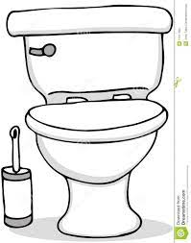**Expliquez l’entretien de ce toilette, comment le nettoyez-vous. Schématiser sur le dessin**.

**Décrivez-moi les étapes :**

* _ _ _ _ _ _ _ _ _ _ _ _ _ _ _ _ _ _ _ _ _ _ _ _ _ _ _ _ _ _ _ _ _ _ _ _ _ _ _ _ _ _ _ _ _ _ _ _ _ _ _ _ _ _ _ _ _ _ _
* _ _ _ _ _ _ _ _ _ _ _ _ _ _ _ _ _ _ _ _ _ _ _ _ _ _ _ _ _ _ _ _ _ _ _ _ _ _ _ _ _ _ _ _ _ _ _ _ _ _ _ _ _ _ _ _ _ _ _
* _ _ _ _ _ _ _ _ _ _ _ _ _ _ _ _ _ _ _ _ _ _ _ _ _ _ _ _ _ _ _ _ _ _ _ _ _ _ _ _ _ _ _ _ _ _ _ _ _ _ _ _ _ _ _ _ _ _ _
* _ _ _ _ _ _ _ _ _ _ _ _ _ _ _ _ _ _ _ _ _ _ _ _ _ _ _ _ _ _ _ _ _ _ _ _ _ _ _ _ _ _ _ _ _ _ _ _ _ _ _ _ _ _ _ _ _ _ _
* _ _ _ _ _ _ _ _ _ _ _ _ _ _ _ _ _ _ _ _ _ _ _ _ _ _ _ _ _ _ _ _ _ _ _ _ _ _ _ _ _ _ _ _ _ _ _ _ _ _ _ _ _ _ _ _ _ _ _
* _ _ _ _ _ _ _ _ _ _ _ _ _ _ _ _ _ _ _ _ _ _ _ _ _ _ _ _ _ _ _ _ _ _ _ _ _ _ _ _ _ _ _ _ _ _ _ _ _ _ _ _ _ _ _ _ _ _ _
* _ _ _ _ _ _ _ _ _ _ _ _ _ _ _ _ _ _ _ _ _ _ _ _ _ _ _ _ _ _ _ _ _ _ _ _ _ _ _ _ _ _ _ _ _ _ _ _ _ _ _ _ _ _ _ _ _ _ _
* _ _ _ _ _ _ _ _ _ _ _ _ _ _ _ _ _ _ _ _ _ _ _ _ _ _ _ _ _ _ _ _ _ _ _ _ _ _ _ _ _ _ _ _ _ _ _ _ _ _ _ _ _ _ _ _ _ _ _

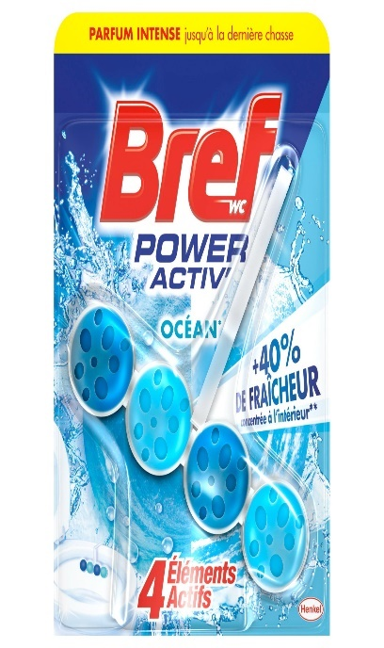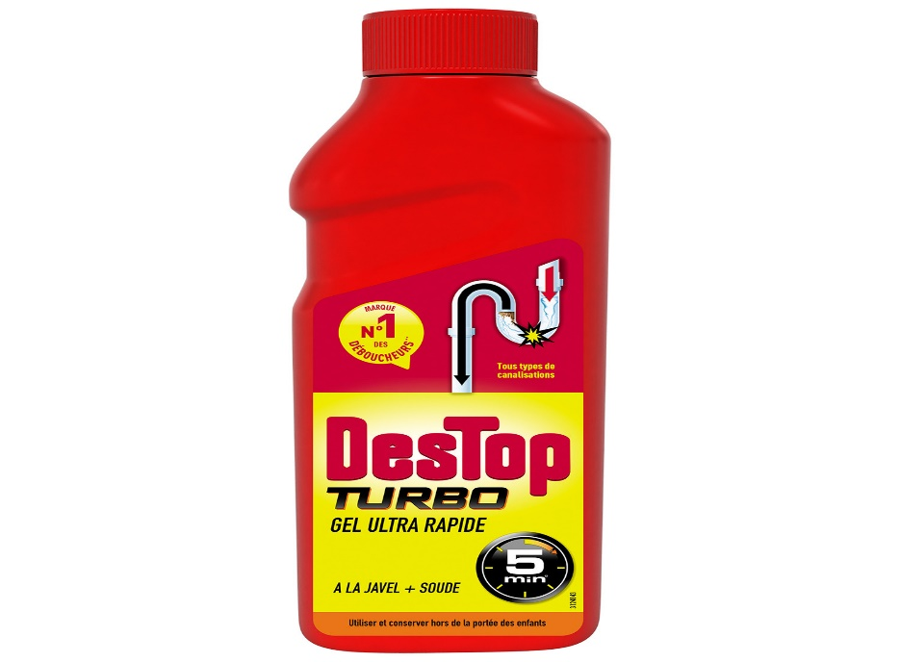**Quels sont ses produits ; quelle est leur efficacité ; où les utiliser ?**

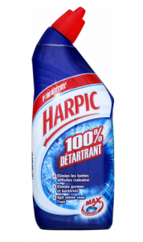

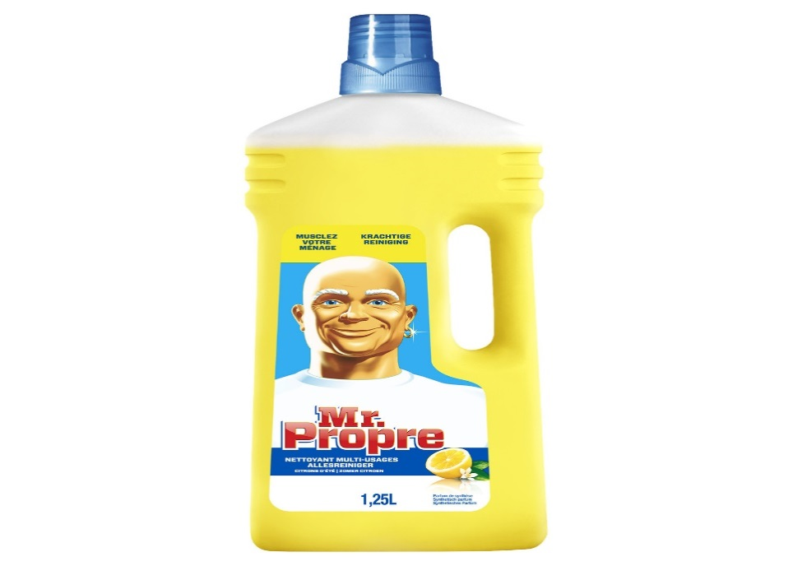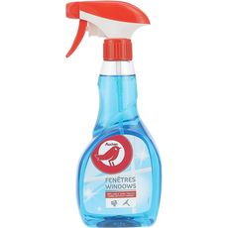

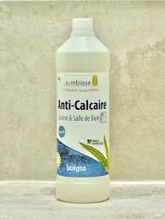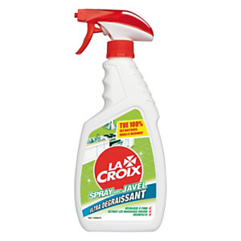**Quels sont ses produits ; quelle est leur efficacité ; où les utiliser ?**

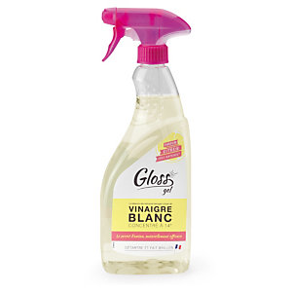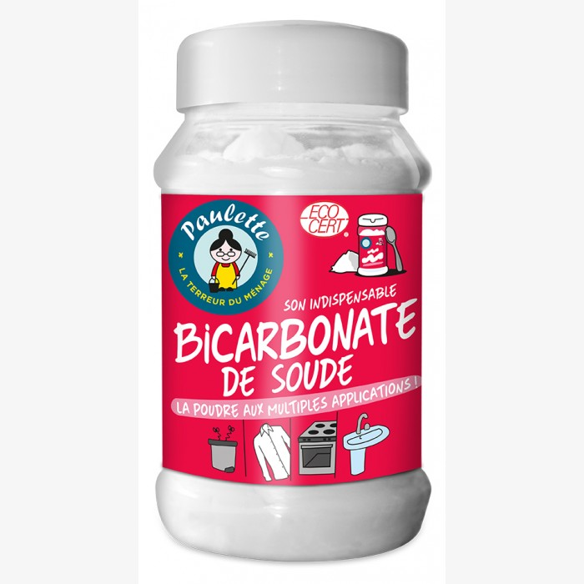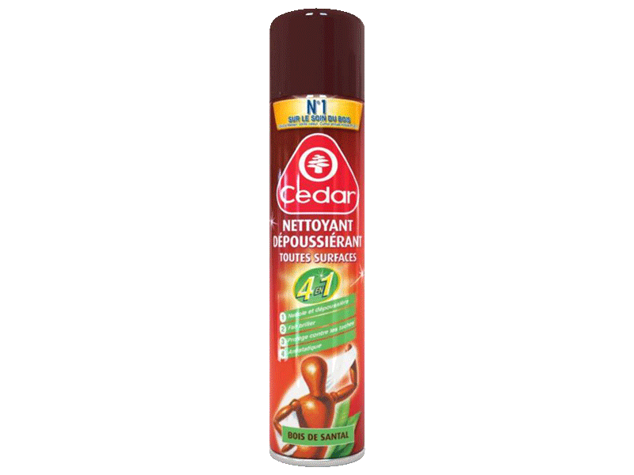

**Dépoussiérage des sols, comment *vous* organisez vous sans gêner la personne aidée ?**



**Décrivez-moi les étapes :**

* _ _ _ _ _ _ _ _ _ _ _ _ _ _ _ _ _ _ _ _ _ _ _ _ _ _ _ _ _ _ _ _ _ _ _ _ _ _ _ _ _ _ _ _ _ _ _ _ _ _ _ _ _ _ _ _ _ _ _
* _ _ _ _ _ _ _ _ _ _ _ _ _ _ _ _ _ _ _ _ _ _ _ _ _ _ _ _ _ _ _ _ _ _ _ _ _ _ _ _ _ _ _ _ _ _ _ _ _ _ _ _ _ _ _ _ _ _ _
* _ _ _ _ _ _ _ _ _ _ _ _ _ _ _ _ _ _ _ _ _ _ _ _ _ _ _ _ _ _ _ _ _ _ _ _ _ _ _ _ _ _ _ _ _ _ _ _ _ _ _ _ _ _ _ _ _ _ _
* _ _ _ _ _ _ _ _ _ _ _ _ _ _ _ _ _ _ _ _ _ _ _ _ _ _ _ _ _ _ _ _ _ _ _ _ _ _ _ _ _ _ _ _ _ _ _ _ _ _ _ _ _ _ _ _ _ _ _
* _ _ _ _ _ _ _ _ _ _ _ _ _ _ _ _ _ _ _ _ _ _ _ _ _ _ _ _ _ _ _ _ _ _ _ _ _ _ _ _ _ _ _ _ _ _ _ _ _ _ _ _ _ _ _ _ _ _ _

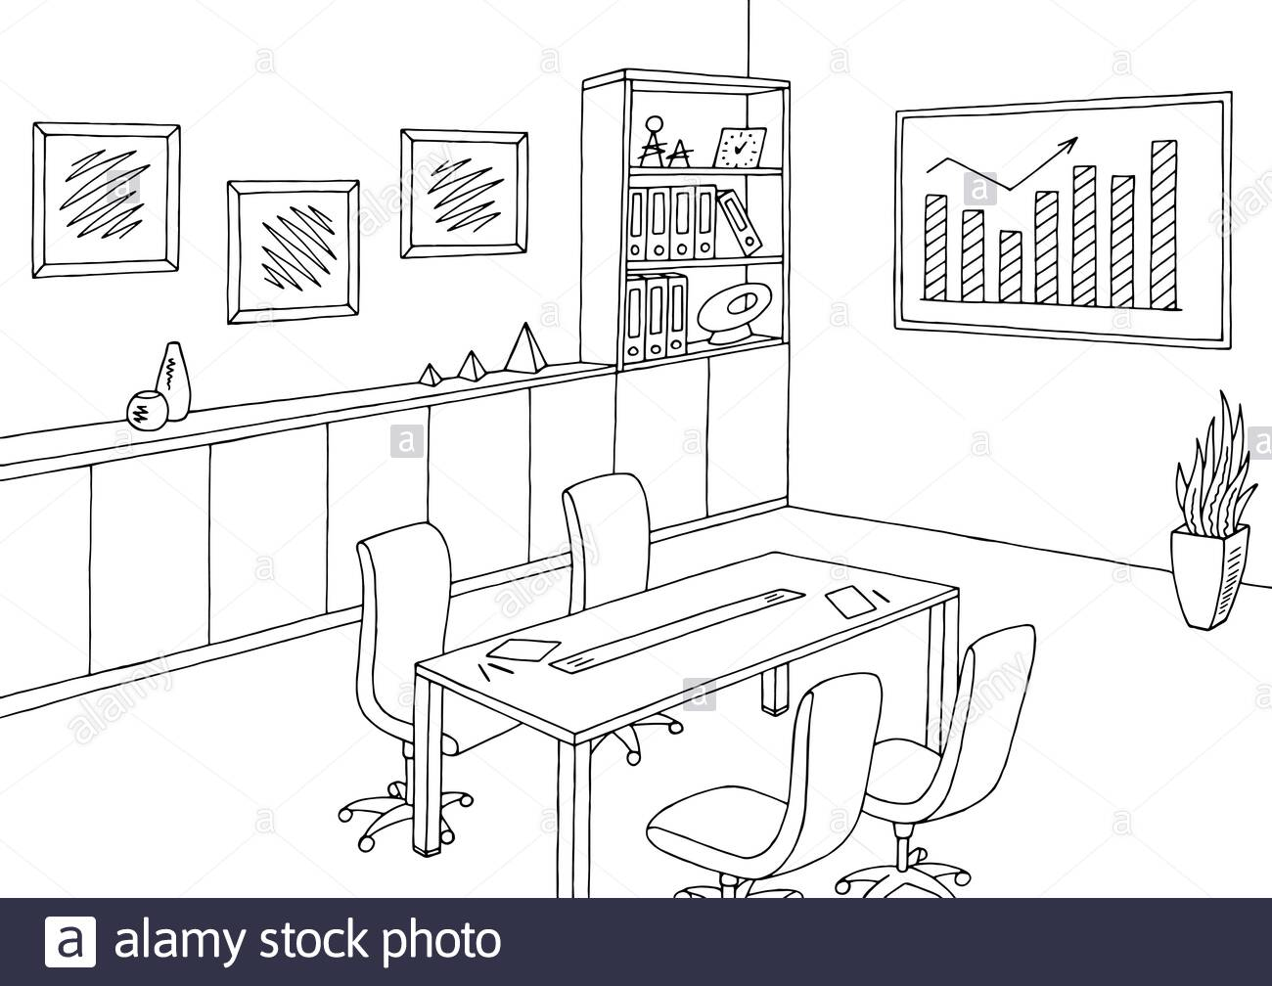**Vous devez faire l’entretien total de cette pièce comment vous organisez vous sans gêner la personne aidée ?**

**Décrivez-moi les étapes :**

* _ _ _ _ _ _ _ _ _ _ _ _ _ _ _ _ _ _ _ _ _ _ _ _ _ _ _ _ _ _ _ _ _ _ _ _ _ _ _ _ _ _ _ _ _ _ _ _ _ _ _ _ _ _ _ _ _ _ _
* _ _ _ _ _ _ _ _ _ _ _ _ _ _ _ _ _ _ _ _ _ _ _ _ _ _ _ _ _ _ _ _ _ _ _ _ _ _ _ _ _ _ _ _ _ _ _ _ _ _ _ _ _ _ _ _ _ _ _
* _ _ _ _ _ _ _ _ _ _ _ _ _ _ _ _ _ _ _ _ _ _ _ _ _ _ _ _ _ _ _ _ _ _ _ _ _ _ _ _ _ _ _ _ _ _ _ _ _ _ _ _ _ _ _ _ _ _ _
* _ _ _ _ _ _ _ _ _ _ _ _ _ _ _ _ _ _ _ _ _ _ _ _ _ _ _ _ _ _ _ _ _ _ _ _ _ _ _ _ _ _ _ _ _ _ _ _ _ _ _ _ _ _ _ _ _ _ _
* _ _ _ _ _ _ _ _ _ _ _ _ _ _ _ _ _ _ _ _ _ _ _ _ _ _ _ _ _ _ _ _ _ _ _ _ _ _ _ _ _ _ _ _ _ _ _ _ _ _ _ _ _ _ _ _ _ _ _

**Vous devez nettoyer cette salle de bain, comment vous organisez vous sans gêner la personne aidée ?**

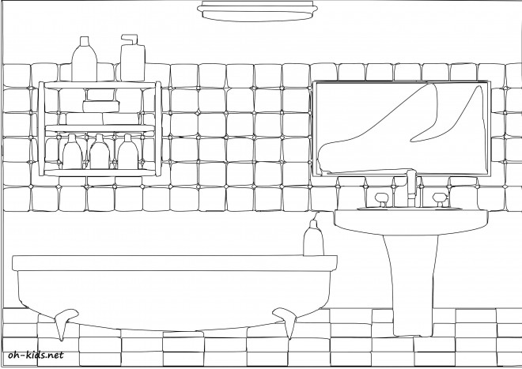

**Décrivez-moi les étapes :**

* _ _ _ _ _ _ _ _ _ _ _ _ _ _ _ _ _ _ _ _ _ _ _ _ _ _ _ _ _ _ _ _ _ _ _ _ _ _ _ _ _ _ _ _ _ _ _ _ _ _ _ _ _ _ _ _ _ _ _
* _ _ _ _ _ _ _ _ _ _ _ _ _ _ _ _ _ _ _ _ _ _ _ _ _ _ _ _ _ _ _ _ _ _ _ _ _ _ _ _ _ _ _ _ _ _ _ _ _ _ _ _ _ _ _ _ _ _ _
* _ _ _ _ _ _ _ _ _ _ _ _ _ _ _ _ _ _ _ _ _ _ _ _ _ _ _ _ _ _ _ _ _ _ _ _ _ _ _ _ _ _ _ _ _ _ _ _ _ _ _ _ _ _ _ _ _ _ _
* _ _ _ _ _ _ _ _ _ _ _ _ _ _ _ _ _ _ _ _ _ _ _ _ _ _ _ _ _ _ _ _ _ _ _ _ _ _ _ _ _ _ _ _ _ _ _ _ _ _ _ _ _ _ _ _ _ _ _
* _ _ _ _ _ _ _ _ _ _ _ _ _ _ _ _ _ _ _ _ _ _ _ _ _ _ _ _ _ _ _ _ _ _ _ _ _ _ _ _ _ _ _ _ _ _ _ _ _ _ _ _ _ _ _ _ _ _ _
* _ _ _ _ _ _ _ _ _ _ _ _ _ _ _ _ _ _ _ _ _ _ _ _ _ _ _ _ _ _ _ _ _ _ _ _ _ _ _ _ _ _ _ _ _ _ _ _ _ _ _ _ _ _ _ _ _ _ _
* _ _ _ _ _ _ _ _ _ _ _ _ _ _ _ _ _ _ _ _ _ _ _ _ _ _ _ _ _ _ _ _ _ _ _ _ _ _ _ _ _ _ _ _ _ _ _ _ _ _ _ _ _ _ _ _ _ _ _

**Comment vous organisez vous pour nettoyer cette suite parentale sans gêner la personne aidée**

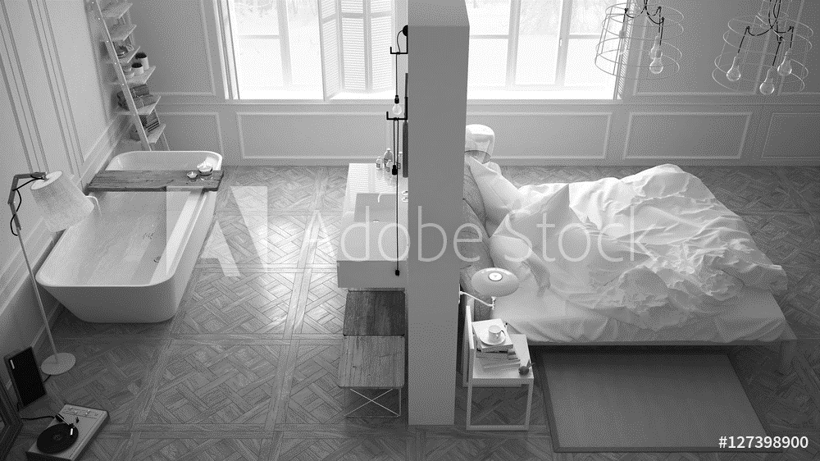

**Décrivez-moi les étapes :**

* _ _ _ _ _ _ _ _ _ _ _ _ _ _ _ _ _ _ _ _ _ _ _ _ _ _ _ _ _ _ _ _ _ _ _ _ _ _ _ _ _ _ _ _ _ _ _ _ _ _ _ _ _ _ _ _ _ _ _
* _ _ _ _ _ _ _ _ _ _ _ _ _ _ _ _ _ _ _ _ _ _ _ _ _ _ _ _ _ _ _ _ _ _ _ _ _ _ _ _ _ _ _ _ _ _ _ _ _ _ _ _ _ _ _ _ _ _ _
* _ _ _ _ _ _ _ _ _ _ _ _ _ _ _ _ _ _ _ _ _ _ _ _ _ _ _ _ _ _ _ _ _ _ _ _ _ _ _ _ _ _ _ _ _ _ _ _ _ _ _ _ _ _ _ _ _ _ _
* _ _ _ _ _ _ _ _ _ _ _ _ _ _ _ _ _ _ _ _ _ _ _ _ _ _ _ _ _ _ _ _ _ _ _ _ _ _ _ _ _ _ _ _ _ _ _ _ _ _ _ _ _ _ _ _ _ _ _
* _ _ _ _ _ _ _ _ _ _ _ _ _ _ _ _ _ _ _ _ _ _ _ _ _ _ _ _ _ _ _ _ _ _ _ _ _ _ _ _ _ _ _ _ _ _ _ _ _ _ _ _ _ _ _ _ _ _ _
* _ _ _ _ _ _ _ _ _ _ _ _ _ _ _ _ _ _ _ _ _ _ _ _ _ _ _ _ _ _ _ _ _ _ _ _ _ _ _ _ _ _ _ _ _ _ _ _ _ _ _ _ _ _ _ _ _ _ _
* _ _ _ _ _ _ _ _ _ _ _ _ _ _ _ _ _ _ _ _ _ _ _ _ _ _ _ _ _ _ _ _ _ _ _ _ _ _ _ _ _ _ _ _ _ _ _ _ _ _ _ _ _ _ _ _ _ _ _
* _ _ _ _ _ _ _ _ _ _ _ _ _ _ _ _ _ _ _ _ _ _ _ _ _ _ _ _ _ _ _ _ _ _ _ _ _ _ _ _ _ _ _ _ _ _ _ _ _ _ _ _ _ _ _ _ _ _ _

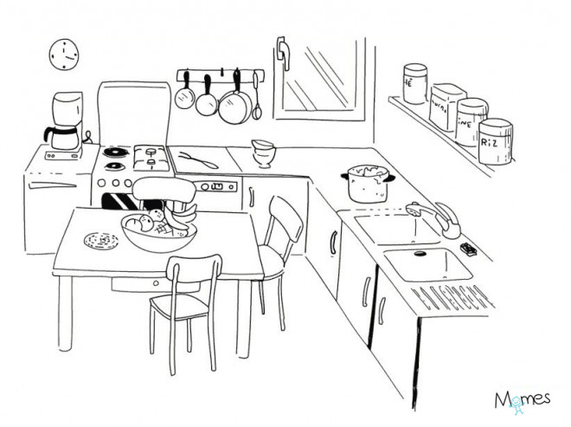**Vous devez entretenir la cuisine, comment vous organisez vous sans gêner la personne aidée ?**

**Décrivez-moi les étapes :**

* _ _ _ _ _ _ _ _ _ _ _ _ _ _ _ _ _ _ _ _ _ _ _ _ _ _ _ _ _ _ _ _ _ _ _ _ _ _ _ _ _ _ _ _ _ _ _ _ _ _ _ _ _ _ _ _ _ _ _
* _ _ _ _ _ _ _ _ _ _ _ _ _ _ _ _ _ _ _ _ _ _ _ _ _ _ _ _ _ _ _ _ _ _ _ _ _ _ _ _ _ _ _ _ _ _ _ _ _ _ _ _ _ _ _ _ _ _ _
* _ _ _ _ _ _ _ _ _ _ _ _ _ _ _ _ _ _ _ _ _ _ _ _ _ _ _ _ _ _ _ _ _ _ _ _ _ _ _ _ _ _ _ _ _ _ _ _ _ _ _ _ _ _ _ _ _ _ _
* _ _ _ _ _ _ _ _ _ _ _ _ _ _ _ _ _ _ _ _ _ _ _ _ _ _ _ _ _ _ _ _ _ _ _ _ _ _ _ _ _ _ _ _ _ _ _ _ _ _ _ _ _ _ _ _ _ _ _
* _ _ _ _ _ _ _ _ _ _ _ _ _ _ _ _ _ _ _ _ _ _ _ _ _ _ _ _ _ _ _ _ _ _ _ _ _ _ _ _ _ _ _ _ _ _ _ _ _ _ _ _ _ _ _ _ _ _ _
* _ _ _ _ _ _ _ _ _ _ _ _ _ _ _ _ _ _ _ _ _ _ _ _ _ _ _ _ _ _ _ _ _ _ _ _ _ _ _ _ _ _ _ _ _ _ _ _ _ _ _ _ _ _ _ _ _ _ _
* _ _ _ _ _ _ _ _ _ _ _ _ _ _ _ _ _ _ _ _ _ _ _ _ _ _ _ _ _ _ _ _ _ _ _ _ _ _ _ _ _ _ _ _ _ _ _ _ _ _ _ _ _ _ _ _ _ _ _
* _ _ _ _ _ _ _ _ _ _ _ _ _ _ _ _ _ _ _ _ _ _ _ _ _ _ _ _ _ _ _ _ _ _ _ _ _ _ _ _ _ _ _ _ _ _ _ _ _ _ _ _ _ _ _ _ _ _ _
* _ _ _ _ _ _ _ _ _ _ _ _ _ _ _ _ _ _ _ _ _ _ _ _ _ _ _ _ _ _ _ _ _ _ _ _ _ _ _ _ _ _ _ _ _ _ _ _ _ _ _ _ _ _ _ _ _ _ _

**Vous devez changer une ampoule, quelle précaution allez-vous prendre ?**

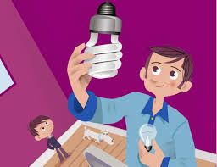 **Décrivez votre action**

* _ _ _ _ _ _ _ _ _ _ _ _ _ _ _ _ _ _ _ _ _ _ _ _ _ _ _ _ _ _ _ _ _ _ _ _ _ _
* _ _ _ _ _ _ _ _ _ _ _ _ _ _ _ _ _ _ _ _ _ _ _ _ _ _ _ _ _ _ _ _ _ _ _ _ _ _
* _ _ _ _ _ _ _ _ _ _ _ _ _ _ _ _ _ _ _ _ _ _ _ _ _ _ _ _ _ _ _ _ _ _ _ _ _ _
* _ _ _ _ _ _ _ _ _ _ _ _ _ _ _ _ _ _ _ _ _ _ _ _ _ _ _ _ _ _ _ _ _ _ _ _ _ _
* _ _ _ _ _ _ _ _ _ _ _ _ _ _ _ _ _ _ _ _ _ _ _ _ _ _ _ _ _ _ _ _ _ _ _ _ _ _
* _ _ _ _ _ _ _ _ _ _ _ _ _ _ _ _ _ _ _ _ _ _ _ _ _ _ _ _ _ _ _ _ _ _ _ _ _ _

**Comment nettoyer le four micro-onde ?**

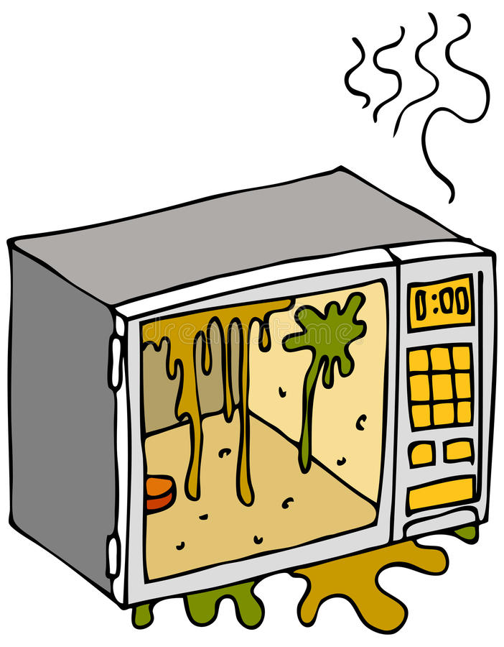**Décrivez votre action :**

* _ _ _ _ _ _ _ _ _ _ _ _ _ _ _ _ _ _ _ _ _ _ _ _ _ _ _ _ _ _ _ _ _ _ _ _ _ _
* _ _ _ _ _ _ _ _ _ _ _ _ _ _ _ _ _ _ _ _ _ _ _ _ _ _ _ _ _ _ _ _ _ _ _ _ _ _
* _ _ _ _ _ _ _ _ _ _ _ _ _ _ _ _ _ _ _ _ _ _ _ _ _ _ _ _ _ _ _ _ _ _ _ _ _ _
* _ _ _ _ _ _ _ _ _ _ _ _ _ _ _ _ _ _ _ _ _ _ _ _ _ _ _ _ _ _ _ _ _ _ _ _ _ _
* _ _ _ _ _ _ _ _ _ _ _ _ _ _ _ _ _ _ _ _ _ _ _ _ _ _ _ _ _ _ _ _ _ _ _ _ _ _
* _ _ _ _ _ _ _ _ _ _ _ _ _ _ _ _ _ _ _ _ _ _ _ _ _ _ _ _ _ _ _ _ _ _ _ _ _ _

_ _ _ _ _ _ _ _ _ _ _ _ _ _ _ _ _ _ _ _ _ _ _ _ _ _ _ _ _ _ _ _ _ _ _ _ _ _ _ _ _ _ _ _ _ _ _ _ _ _ _ _ _ _ _ _ _ _ _ _ _ _ _ _ _

_ _ _ _ _ _ _ _ _ _ _ _ _ _ _ _ _ _ _ _ _ _ _ _ _ _ _ _ _ _ _ _ _ _ _ _ _ _ _ _ _ _ _ _ _ _ _ _ _ _ _ _ _ _ _ _ _ _ _ _ _ _ _ _ _

_ _ _ _ _ _ _ _ _ _ _ _ _ _ _ _ _ _ _ _ _ _ _ _ _ _ _ _ _ _ _ _ _ _ _ _ _ _ _ _ _ _ _ _ _ _ _ _ _ _ _ _ _ _ _ _ _ _ _ _ _ _ _ _ _

_ _ _ _ _ _ _ _ _ _ _ _ _ _ _ _ _ _ _ _ _ _ _ _ _ _ _ _ _ _ _ _ _ _ _ _ _ _ _ _ _ _ _ _ _ _ _ _ _ _ _ _ _ _ _ _ _ _ _ _ _ _ _ _ _

_ _ _ _ _ _ _ _ _ _ _ _ _ _ _ _ _ _ _ _ _ _ _ _ _ _ _ _ _ _ _ _ _ _ _ _ _ _ _ _ _ _ _ _ _ _ _ _ _ _ _ _ _ _ _ _ _ _ _ _ _ _ _ _ _

_ _ _ _ _ _ _ _ _ _ _ _ _ _ _ _ _ _ _ _ _ _ _ _ _ _ _ _ _ _ _ _ _ _ _ _ _ _ _ _ _ _ _ _ _ _ _ _ _ _ _ _ _ _ _ _ _ _ _ _ _ _ _ _ _

_ _ _ _ _ _ _ _ _ _ _ _ _ _ _ _ _ _ _ _ _ _ _ _ _ _ _ _ _ _ _ _ _ _ _ _ _ _ _ _ _ _ _ _ _ _ _ _ _ _ _ _ _ _ _ _ _ _ _ _ _ _ _ _ _

_ _ _ _ _ _ _ _ _ _ _ _ _ _ _ _ _ _ _ _ _ _ _ _ _ _ _ _ _ _ _ _ _ _ _ _ _ _ _ _ _ _ _ _ _ _ _ _ _ _ _ _ _ _ _ _ _ _ _ _ _ _ _ _ _

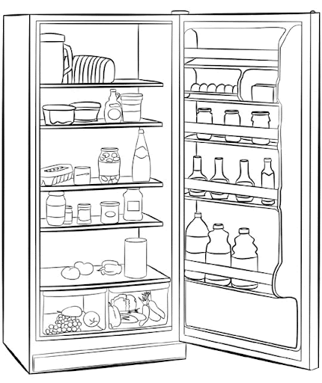**Vous devez nettoyer le réfrigérateur, comment faites-vous ?**

**Votre réponse :**

* _ _ _ _ _ _ _ _ _ _ _ _ _ _ _ _ _ _ _ _ _ _ _ _ _ _ _ _ _ _ _ _ _ _ _ _ _ _ _ _ _ _ _ _ _ _ _ _ _ _ _ _ _ _ _ _ _
* _ _ _ _ _ _ _ _ _ _ _ _ _ _ _ _ _ _ _ _ _ _ _ _ _ _ _ _ _ _ _ _ _ _ _ _ _ _ _ _ _ _ _ _ _ _ _ _ _ _ _ _ _ _ _ _ _
* _ _ _ _ _ _ _ _ _ _ _ _ _ _ _ _ _ _ _ _ _ _ _ _ _ _ _ _ _ _ _ _ _ _ _ _ _ _ _ _ _ _ _ _ _ _ _ _ _ _ _ _ _ _ _ _ _
* _ _ _ _ _ _ _ _ _ _ _ _ _ _ _ _ _ _ _ _ _ _ _ _ _ _ _ _ _ _ _ _ _ _ _ _ _ _ _ _ _ _ _ _ _ _ _ _ _ _ _ _ _ _ _ _ __ _ _ _ _ _ _ _ _ _ _ _ _ _ _ _ _ _ _ _ _ _ _ _ _ _ _ _ _ _ _ _ _ _ _ _ _ _ _ _ _ _ _

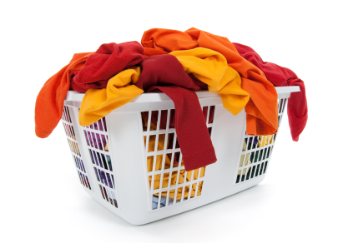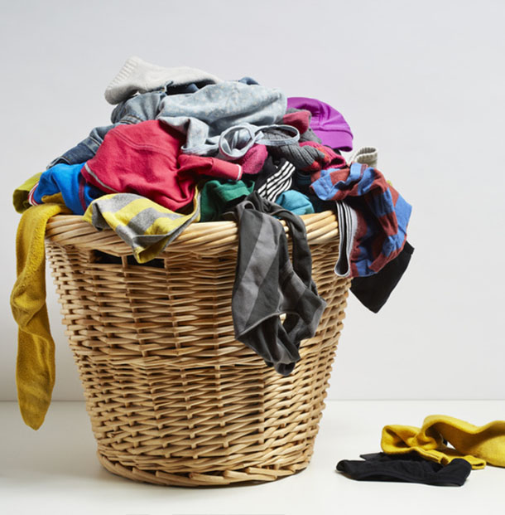

**Vous triez le linge, à quoi devez vous faire attention, qu’est-ce qui vous permet de faire le tri correctement ?**

* _ _ _ _ _ _ _ _ _ _ _ _ _ _ _ _ _ _ _ _ _ _ _ _ _ _ _ _ _ _ _ _ _ _ _ _ _ _ _ _ _ _ _ _ _ _ _ _ _ _ _ _ _ _ _ _ _ _ _ _ _
* _ _ _ _ _ _ _ _ _ _ _ _ _ _ _ _ _ _ _ _ _ _ _ _ _ _ _ _ _ _ _ _ _ _ _ _ _ _ _ _ _ _ _ _ _ _ _ _ _ _ _ _ _ _ _ _ _ _ _ _ _
* _ _ _ _ _ _ _ _ _ _ _ _ _ _ _ _ _ _ _ _ _ _ _ _ _ _ _ _ _ _ _ _ _ _ _ _ _ _ _ _ _ _ _ _ _ _ _ _ _ _ _ _ _ _ _ _ _ _ _ _ _
* _ _ _ _ _ _ _ _ _ _ _ _ _ _ _ _ _ _ _ _ _ _ _ _ _ _ _ _ _ _ _ _ _ _ _ _ _ _ _ _ _ _ _ _ _ _ _ _ _ _ _ _ _ _ _ _ _ _ _ _ _
* _ _ _ _ _ _ _ _ _ _ _ _ _ _ _ _ _ _ _ _ _ _ _ _ _ _ _ _ _ _ _ _ _ _ _ _ _ _ _ _ _ _ _ _ _ _ _ _ _ _ _ _ _ _ _ _ _ _ _ _ _
* _ _ _ _ _ _ _ _ _ _ _ _ _ _ _ _ _ _ _ _ _ _ _ _ _ _ _ _ _ _ _ _ _ _ _ _ _ _ _ _ _ _ _ _ _ _ _ _ _ _ _ _ _ _ _ _ _ _ _ _ _

**Selon les pictogrammes représentés, à quelle action correspondent-ils ?**



**Votre réponse :**

**Votre réponse :**

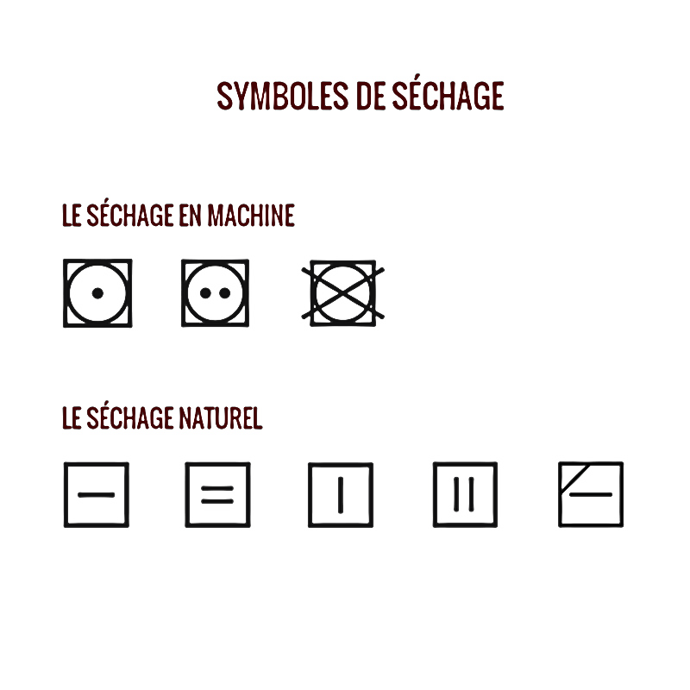

**Votre réponse :**

**Votre réponse :**

**Votre réponse :**



**Votre réponse :**

* .

**Quand il y a une croix sur le symbole qu’est-ce que cela signifie X ?**

**Expliquer le lavage des mains et en combien de temps ?**

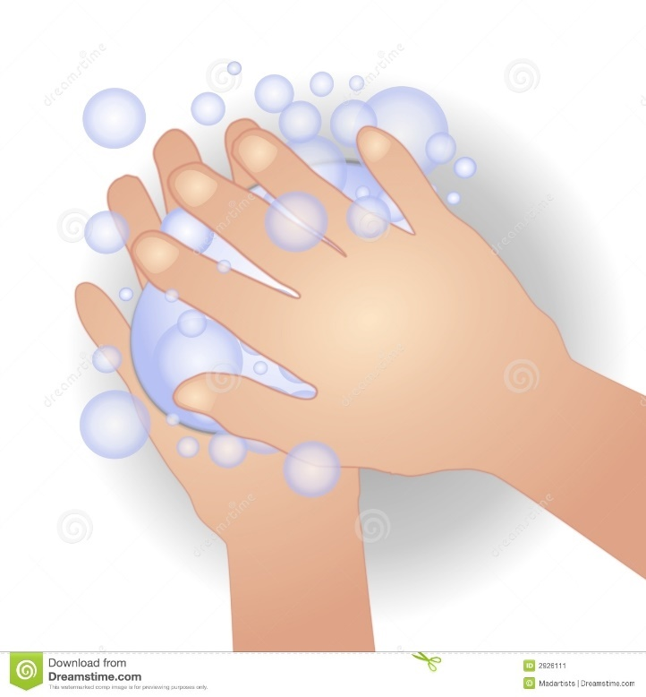

**Votre réponse :** _ _ _ _ _ _ _ _ _ _ _ _ _ _ _ _ _ _ _ _ _ _ _ _ _ _ _ _ _ _ _ _ _ _ _ _ _ _ _ _ _ _ _ _ _ _ _ _ _ _ _ _ _ _ _ _ _ _ _ _ __ _ _ _ _ _ _ _ _ _ _ _ _ _ _ _ _ _ _ _ _ _ _ _ _ _ _ _ _ _ _ _ _ _ _ _ _ _ _ _ _ _ _ _ _ _ _ _ _ _ _ _ _ _ _ _ _ _ _ _ __ _ _ _ _ _ _ _ _ _ _ _ _ _ _ _ _ _ _ _ _ _ _ _ _ _ _ _ _ _ _ _ _ _ _ _ _ _ _ _ _ _ _ _ _ _ _ _ _ _ _ _ _ _ _ _ _ _ _ _ __ _ _ _ _ _ _ _ _ _ _ _ _ _ _ _ _ _ _ _ _ _ _ _ _ _ _ _ _ _ _ _ _ _ _ _ _ _ _ _ _ _ _ _ _ _ _ _ _ _ _ _ _ _ _ _ _ _ _ _ __ _ _ _ _ _ _ _ _ _ _ _ _ _ _ _ _ _ _ _ _ _ _ _ _ _ _ _ _ _ _ _ _ _ _ _ _ _ _ _ _ _ _ _ _ _ _ _ _ _ _ _ _ _ _ _ _ _ _ _ __ _ _ _ _ _ _ _ _ _ _ _ _ _ _ _ _ _ _ _ _ _ _ _ _ _ _ _ _ _ _ _ _ _ _ _ _ _ _ _ _ _ _ _ _ _ _ _ _ _ _ _ _ _ _ _ _ _ _ _ __ _ _ _ _ _ _ _ _ _ _ _ _ _ _ _ _ _ _ _ _ _ _ _ _ _ _ _ _ _ _ _ _ _ _ _ _ _ _ _ _ _ _ _ _ _ _ _ _ _ _ _ _ _ _ _ _ _ _ _ __ _ _ _ _ _ _ _ _ _ _ _ _ _ _ _ _ _ _ _ _ _ _ _ _ _ _ _ _ _ _ _ _ _ _ _ _ _ _ _ _ _ _ _ _ _ _ _ _ _ _ _ _ _ _ _ _ _ _ _ __ _ _ _ _ _ _ _ _ _ _ _ _ _ _ _ _ _ _ _ _ _ _ _ _ _ _ _ _ _ _ _ _ _ _ _ _ _ _ _ _ _ _ _ _ _ _ _ _ _ _ _ _ _ _ _ _ _ _ _ __ _ _ _ _ _ _ _ _ _ _ _ _ _ _ _ _ _ _ _ _ _ _ _ _ _ _ _ _ _ _ _ _ _ _ _ _ _ _ _ _ _ _ _ _ _ _ _ _ _ _ _ _ _ _ _ _ _ _ _ __ _ _ _ _ _ _ _ _ _ _ _ _ _ _ _ _ _ _ _ _ _ _ _ _ _ _ _ _ _ _ _ _ _ _ _ _ _ _ _ _ _ _ _ _ _ _ _ _ _ _ _ _ _ _ _ _ _ _ _ __ _ _ _ _ _ _ _ _ _ _ _ _ _ _ _ _ _ _ _ _ _ _ _ _ _ _ _ _ _ _ _ _ _ _ _ _ _ _ _ _ _ _ _ _ _ _ _ _ _ _ _ _ _ _ _ _ _ _ _ __ _ _ _ _ _ _ _ _ _ _ _ _ _ _ _ _ _ _ _ _ _ _ _ _ _ _ _ _ _ _ _ _ _ _ _ _ _ _ _ _ _ _ _ _ _ _ _ _ _ _ _ _ _ _ _ _ _ _ _ __ _ _ _ _ _ _ _ _ _ _ _ _ _ _ _ _ _ _ _ _ _ _ _ _ _ _ _ _ _ _ _ _ _ _ _ _ _ _ _ _ _ _ _ _ _ _



_ _ _ _ _ _ _ _ _ _ _ _ _ _ _ _ _ _ _ _ _ _ _ _ _ _ _ _ _ _ _ _ _ _ _ _ _ _ _ _ _ _ _ _ _ _ _ _ _ _ _ _ _ _ _ _ _ _ _ _ __ _ _ _ _ _ _ _ _ _ _ _ _ _ _ _ _ _ _ _ _ _ _ _ _ _ _ _ _ _ _ _ _ _ _ _ _ _ _ _ _ _ _ _ _ _ _ _ _ _ _ _ _ _ _ _ _ _ _ _ __ _ _ _ _ _ _ _ _ _ _ _ _ _ _ _ _ _ _ _ _ _ _ _ _ _ _ _ _ _ _ _ _ _ _ _ _ _ _ _ _ _ _ _ _ _ _ _ _ _ _ _ _ _ _ _ _ _ _ _ __ _ _ _ _ _ _ _ _ _ _ _ _ _ _ _ _ _ _ _ _ _ _ _ _ _ _ _ _ _ _ _ _ _ _ _ _ _ _ _ _ _ _ _ _ _ _ _ _ _ _ _ _ _ _ _ _ _ _ _ __ _ _ _ _ _ _ _ _ _ _ _ _ _ _ _ _ _ _ _ _ _ _ _ _ _ _ _ _ _ _ _ _ _ _ _ _ _ _ _ _ _ _ _ _ _ _ _ _ _ _ _ _ _ _ _ _ _ _ _ __ _ _ _ _ _ _ _ _ _ _ _ _ _ _ _ _ _ _ _ _ _ _ _ _ _ _ _ _ _ _ _ _ _ _ _ _ _ _ _ _ _ _ _ _ _ _ _ _ _ _ _ _ _ _ _ _ _ _ _ __ _ _ _ _ _ _ _ _ _ _ _ _ _ _ _ _ _ _ _ _ _ _ _ _ _ _ _ _ _ _ _ _ _ _ _ _ _ _ _ _ _ _ _ _ _ _ _ _ _ _ _ _ _ _ _ _ _ _ _ __ _ _ _ _ _ _ _ _ _ _ _ _ _ _ _ _ _ _ _ _ _ _ _ _ _ _ _ _ _ _ _ _ _ _ _ _ _ _ _ _ _ _ _ _ _ _ _ _ _ _ _ _ _ _ _ _ _ _ _ __ _ _ _ _ _ _ _ _ _ _ _ _ _ _ _ _ _ _ _ _ _ _ _ _ _ _ _ _ _ _ _ _ _ _ _ _ _ _ _ _ _ _ _ _ _ _ _ _ _ _ _ _ _ _ _ _ _ _ _ __ _ _ _ _ _ _ _ _ _ _ _ _ _ _ _ _ _ _ _ _ _ _ _ _ _ _ _ _ _ _ _ _ _ _ _ _ _ _ _ _ _ _ _ _ _ _ _ _ _ _ _ _ _ _ _ _ _ _ _ __ _ _ _ _ _ _ _ _ _ _ _ _ _ _ _ _ _ _ _ _ _ _ _ _ _ _ _ _ _ _ _ _ _ _ _ _ _ _ _ _ _ _ _ _ _ _ _ _ _ _ _ _ _ _ _ _ _ _ _ __ _ _ _ _ _ _ _ _ _ _ _ _ _ _ _ _ _ _ _ _ _ _ _ _ _ _ _ _ _ _ _ _ _ _ _ _ _ _ _ _ _ _ _ _ _ _ _ _ _ _ _ _ _ _ _ _ _ _ _ __ _ _ _ _ _ _ _ _ _ _ _ _ _ _ _ _ _ _ _ _ _ _ _ _ _ _ _ _ _ _ _ _ _ _ _ _ _ _ _ _ _ _ _ _ _ _ _ _ _ _ _ _ _ _ _ _ _ _ _ __ _ _ _ _ _ _ _ _ _ _ _ _ _ _ _ _ _ _ _ _ _ _ _ _ _ _ _ _ _ _ _ _ _ _ _ _ _ _ _ _ _ _ _ _ _ _ _ _ _ _ _ _ _ _ _

|  |
| --- |
|  |
|  |
|  |
|  |
|  |
|  |
|  |
|  |

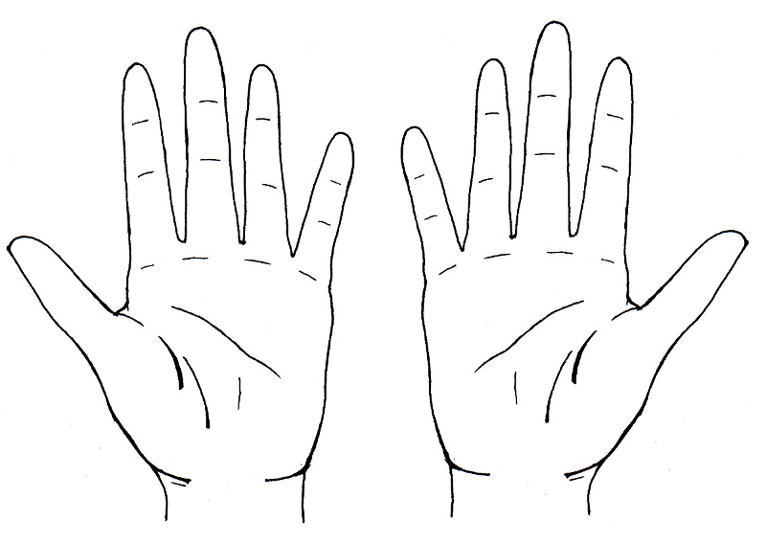**Vous vous lavez les mains, que ne devez-vous pas porter ?**

|  |
| --- |
|  |
|  |
|  |
|  |
|  |
|  |
|  |

Définissez le rôle de l’Assistant(e) De Vie aux Familles lors de son intervention au domicile de la personne aidée

_ _ _ _ _ _ _ _ _ _ _ _ _ _ _ _ _ _ _ _ _ _ _ _ _ _ _ _ _ _ _ _ _ _ _ _ _ _ _ _ _ _ _ _ _ _ _ _ _ _ _ _ _ _ _ _ _ _ _ _ _ _ _ _ _

_ _ _ _ _ _ _ _ _ _ _ _ _ _ _ _ _ _ _ _ _ _ _ _ _ _ _ _ _ _ _ _ _ _ _ _ _ _ _ _ _ _ _ _ _ _ _ _ _ _ _ _ _ _ _ _ _ _ _ _ _ _ _ _ _

_ _ _ _ _ _ _ _ _ _ _ _ _ _ _ _ _ _ _ _ _ _ _ _ _ _ _ _ _ _ _ _ _ _ _ _ _ _ _ _ _ _ _ _ _ _ _ _ _ _ _ _ _ _ _ _ _ _ _ _ _ _ _ _ _

_ _ _ _ _ _ _ _ _ _ _ _ _ _ _ _ _ _ _ _ _ _ _ _ _ _ _ _ _ _ _ _ _ _ _ _ _ _ _ _ _ _ _ _ _ _ _ _ _ _ _ _ _ _ _ _ _ _ _ _ _ _ _ _ _

_ _ _ _ _ _ _ _ _ _ _ _ _ _ _ _ _ _ _ _ _ _ _ _ _ _ _ _ _ _ _ _ _ _ _ _ _ _ _ _ _ _ _ _ _ _ _ _ _ _ _ _ _ _ _ _ _ _ _ _ _ _ _ _ _

_ _ _ _ _ _ _ _ _ _ _ _ _ _ _ _ _ _ _ _ _ _ _ _ _ _ _ _ _ _ _ _ _ _ _ _ _ _ _ _ _ _ _ _ _ _ _ _ _ _ _ _ _ _ _ _ _ _ _ _ _ _ _ _ _

_ _ _ _ _ _ _ _ _ _ _ _ _ _ _ _ _ _ _ _ _ _ _ _ _ _ _ _ _ _ _ _ _ _ _ _ _ _ _ _ _ _ _ _ _ _ _ _ _ _ _ _ _ _ _ _ _ _ _ _ _ _ _ _ _

_ _ _ _ _ _ _ _ _ _ _ _ _ _ _ _ _ _ _ _ _ _ _ _ _ _ _ _ _ _ _ _ _ _ _ _ _ _ _ _ _ _ _ _ _ _ _ _ _ _ _ _ _ _ _ _ _ _ _ _ _ _ _ _ _

Lors de votre première intervention, vous rencontrez pour la première fois la personne aidée, que devez-vous faire ?

_ _ _ _ _ _ _ _ _ _ _ _ _ _ _ _ _ _ _ _ _ _ _ _ _ _ _ _ _ _ _ _ _ _ _ _ _ _ _ _ _ _ _ _ _ _ _ _ _ _ _ _ _ _ _ _ _ _ _ _ _ _ _ _ _

_ _ _ _ _ _ _ _ _ _ _ _ _ _ _ _ _ _ _ _ _ _ _ _ _ _ _ _ _ _ _ _ _ _ _ _ _ _ _ _ _ _ _ _ _ _ _ _ _ _ _ _ _ _ _ _ _ _ _ _ _ _ _ _ _

_ _ _ _ _ _ _ _ _ _ _ _ _ _ _ _ _ _ _ _ _ _ _ _ _ _ _ _ _ _ _ _ _ _ _ _ _ _ _ _ _ _ _ _ _ _ _ _ _ _ _ _ _ _ _ _ _ _ _ _ _ _ _ _ _

_ _ _ _ _ _ _ _ _ _ _ _ _ _ _ _ _ _ _ _ _ _ _ _ _ _ _ _ _ _ _ _ _ _ _ _ _ _ _ _ _ _ _ _ _ _ _ _ _ _ _ _ _ _ _ _ _ _ _ _ _ _ _ _ _

_ _ _ _ _ _ _ _ _ _ _ _ _ _ _ _ _ _ _ _ _ _ _ _ _ _ _ _ _ _ _ _ _ _ _ _ _ _ _ _ _ _ _ _ _ _ _ _ _ _ _ _ _ _ _ _ _ _ _ _ _ _ _ _ _

_ _ _ _ _ _ _ _ _ _ _ _ _ _ _ _ _ _ _ _ _ _ _ _ _ _ _ _ _ _ _ _ _ _ _ _ _ _ _ _ _ _ _ _ _ _ _ _ _ _ _ _ _ _ _ _ _ _ _ _ _ _ _ _ _

_ _ _ _ _ _ _ _ _ _ _ _ _ _ _ _ _ _ _ _ _ _ _ _ _ _ _ _ _ _ _ _ _ _ _ _ _ _ _ _ _ _ _ _ _ _ _ _ _ _ _ _ _ _ _ _ _ _ _ _ _ _ _ _ _

_ _ _ _ _ _ _ _ _ _ _ _ _ _ _ _ _ _ _ _ _ _ _ _ _ _ _ _ _ _ _ _ _ _ _ _ _ _ _ _ _ _ _ _ _ _ _ _ _ _ _ _ _ _ _ _ _ _ _ _ _ _ _ _ _

_ _ _ _ _ _ _ _ _ _ _ _ _ _ _ _ _ _ _ _ _ _ _ _ _ _ _ _ _ _ _ _ _ _ _ _ _ _ _ _ _ _ _ _ _ _ _ _ _ _ _ _ _ _ _ _ _ _ _ _ _ _ _ _ _

_ _ _ _ _ _ _ _ _ _ _ _ _ _ _ _ _ _ _ _ _ _ _ _ _ _ _ _ _ _ _ _ _ _ _ _ _ _ _ _ _ _ _ _ _ _ _ _ _ _ _ _ _ _ _ _ _ _ _ _ _ _ _ _ _

_ _ _ _ _ _ _ _ _ _ _ _ _ _ _ _ _ _ _ _ _ _ _ _ _ _ _ _ _ _ _ _ _ _ _ _ _ _ _ _ _ _ _ _ _ _ _ _ _ _ _ _ _ _ _ _ _ _ _ _ _ _ _ _ _

_ _ _ _ _ _ _ _ _ _ _ _ _ _ _ _ _ _ _ _ _ _ _ _ _ _ _ _ _ _ _ _ _ _ _ _ _ _ _ _ _ _ _ _ _ _ _ _ _ _ _ _ _ _ _ _ _ _ _ _ _ _ _ _ _

_ _ _ _ _ _ _ _ _ _ _ _ _ _ _ _ _ _ _ _ _ _ _ _ _ _ _ _ _ _ _ _ _ _ _ _ _ _ _ _ _ _ _ _ _ _ _ _ _ _ _ _ _ _ _ _ _ _ _ _ _ _ _ _ _

Définissez le rôle de l’Assistant(e) De Vie aux Familles lors de son intervention au domicile de la personne aidée

_ _ _ _ _ _ _ _ _ _ _ _ _ _ _ _ _ _ _ _ _ _ _ _ _ _ _ _ _ _ _ _ _ _ _ _ _ _ _ _ _ _ _ _ _ _ _ _ _ _

_ _ _ _ _ _ _ _ _ _ _ _ _ _ _ _ _ _ _ _ _ _ _ _ _ _ _ _ _ _ _ _ _ _ _ _ _ _ _ _ _ _ _ _ _ _ _ _ _ _

_ _ _ _ _ _ _ _ _ _ _ _ _ _ _ _ _ _ _ _ _ _ _ _ _ _ _ _ _ _ _ _ _ _ _ _ _ _ _ _ _ _ _ _ _ _ _ _ _ _

_ _ _ _ _ _ _ _ _ _ _ _ _ _ _ _ _ _ _ _ _ _ _ _ _ _ _ _ _ _ _ _ _ _ _ _ _ _ _ _ _ _ _ _ _ _ _ _ _ _

_ _ _ _ _ _ _ _ _ _ _ _ _ _ _ _ _ _ _ _ _ _ _ _ _ _ _ _ _ _ _ _ _ _ _ _ _ _ _ _ _ _ _ _ _ _ _ _ _ _

_ _ _ _ _ _ _ _ _ _ _ _ _ _ _ _ _ _ _ _ _ _ _ _ _ _ _ _ _ _ _ _ _ _ _ _ _ _ _ _ _ _ _ _ _ _ _ _ _ _

_ _ _ _ _ _ _ _ _ _ _ _ _ _ _ _ _ _ _ _ _ _ _ _ _ _ _ _ _ _ _ _ _ _ _ _ _ _ _ _ _ _ _ _ _ _ _ _ _ _

_ _ _ _ _ _ _ _ _ _ _ _ _ _ _ _ _ _ _ _ _ _ _ _ _ _ _ _ _ _ _ _ _ _ _ _ _ _ _ _ _ _ _ _ _ _ _ _ _ _

Vous, vous retrouvez pour la première fois devant la personne aidée, c’est votre première intervention que faites-vous ?

_ _ _ _ _ _ _ _ _ _ _ _ _ _ _ _ _ _ _ _ _ _ _ _ _ _ _ _ _ _ _ _ _ _ _ _ _ _ _ _ _ _ _ _ _ _ _ _ _ _

_ _ _ _ _ _ _ _ _ _ _ _ _ _ _ _ _ _ _ _ _ _ _ _ _ _ _ _ _ _ _ _ _ _ _ _ _ _ _ _ _ _ _ _ _ _ _ _ _ _

_ _ _ _ _ _ _ _ _ _ _ _ _ _ _ _ _ _ _ _ _ _ _ _ _ _ _ _ _ _ _ _ _ _ _ _ _ _ _ _ _ _ _ _ _ _ _ _ _ _

_ _ _ _ _ _ _ _ _ _ _ _ _ _ _ _ _ _ _ _ _ _ _ _ _ _ _ _ _ _ _ _ _ _ _ _ _ _ _ _ _ _ _ _ _ _ _ _ _ _

_ _ _ _ _ _ _ _ _ _ _ _ _ _ _ _ _ _ _ _ _ _ _ _ _ _ _ _ _ _ _ _ _ _ _ _ _ _ _ _ _ _ _ _ _ _ _ _ _ _

_ _ _ _ _ _ _ _ _ _ _ _ _ _ _ _ _ _ _ _ _ _ _ _ _ _ _ _ _ _ _ _ _ _ _ _ _ _ _ _ _ _ _ _ _ _ _ _ _ _

_ _ _ _ _ _ _ _ _ _ _ _ _ _ _ _ _ _ _ _ _ _ _ _ _ _ _ _ _ _ _ _ _ _ _ _ _ _ _ _ _ _ _ _ _ _ _ _ _ _

_ _ _ _ _ _ _ _ _ _ _ _ _ _ _ _ _ _ _ _ _ _ _ _ _ _ _ _ _ _ _ _ _ _ _ _ _ _ _ _ _ _ _ _ _ _ _ _ _ _

_ _ _ _ _ _ _ _ _ _ _ _ _ _ _ _ _ _ _ _ _ _ _ _ _ _ _ _ _ _ _ _ _ _ _ _ _ _ _ _ _ _ _ _ _ _ _ _ _ _

_ _ _ _ _ _ _ _ _ _ _ _ _ _ _ _ _ _ _ _ _ _ _ _ _ _ _ _ _ _ _ _ _ _ _ _ _ _ _ _ _ _ _ _ _ _ _ _ _ _

_ _ _ _ _ _ _ _ _ _ _ _ _ _ _ _ _ _ _ _ _ _ _ _ _ _ _ _ _ _ _ _ _ _ _ _ _ _ _ _ _ _ _ _ _ _ _ _ _ _

_ _ _ _ _ _ _ _ _ _ _ _ _ _ _ _ _ _ _ _ _ _ _ _ _ _ _ _ _ _ _ _ _ _ _ _ _ _ _ _ _ _ _ _ _ _ _ _ _ _

_ _ _ _ _ _ _ _ _ _ _ _ _ _ _ _ _ _ _ _ _ _ _ _ _ _ _ _ _ _ _ _ _ _ _ _ _ _ _ _ _ _ _ _ _ _ _ _ _ _

Quand on parle d’organisation, comment allez-vous faire pour optimiser le temps que vous allez passez chez la personne aidée ?

_ _ _ _ _ _ _ _ _ _ _ _ _ _ _ _ _ _ _ _ _ _ _ _ _ _ _ _ _ _ _ _ _ _ _ _ _ _ _ _ _ _ _ _ _ _ _ _ _ _

_ _ _ _ _ _ _ _ _ _ _ _ _ _ _ _ _ _ _ _ _ _ _ _ _ _ _ _ _ _ _ _ _ _ _ _ _ _ _ _ _ _ _ _ _ _ _ _ _ _

_ _ _ _ _ _ _ _ _ _ _ _ _ _ _ _ _ _ _ _ _ _ _ _ _ _ _ _ _ _ _ _ _ _ _ _ _ _ _ _ _ _ _ _ _ _ _ _ _ _

_ _ _ _ _ _ _ _ _ _ _ _ _ _ _ _ _ _ _ _ _ _ _ _ _ _ _ _ _ _ _ _ _ _ _ _ _ _ _ _ _ _ _ _ _ _ _ _ _ _

_ _ _ _ _ _ _ _ _ _ _ _ _ _ _ _ _ _ _ _ _ _ _ _ _ _ _ _ _ _ _ _ _ _ _ _ _ _ _ _ _ _ _ _ _ _ _ _ _ _

_ _ _ _ _ _ _ _ _ _ _ _ _ _ _ _ _ _ _ _ _ _ _ _ _ _ _ _ _ _ _ _ _ _ _ _ _ _ _ _ _ _ _ _ _ _ _ _ _ _

_ _ _ _ _ _ _ _ _ _ _ _ _ _ _ _ _ _ _ _ _ _ _ _ _ _ _ _ _ _ _ _ _ _ _ _ _ _ _ _ _ _ _ _ _ _ _ _ _ _

_ _ _ _ _ _ _ _ _ _ _ _ _ _ _ _ _ _ _ _ _ _ _ _ _ _ _ _ _ _ _ _ _ _ _ _ _ _ _ _ _ _ _ _ _ _ _ _ _ _

Que doit faire en priorité l’Assistant(e) De Vie aux Familles, qu’elle est sa première action professionnelle pour pouvoir garder le lien entre vous et les autres intervenant ?

_ _ _ _ _ _ _ _ _ _ _ _ _ _ _ _ _ _ _ _ _ _ _ _ _ _ _ _ _ _ _ _ _ _ _ _ _ _ _ _ _ _ _ _ _ _ _ _ _ _

_ _ _ _ _ _ _ _ _ _ _ _ _ _ _ _ _ _ _ _ _ _ _ _ _ _ _ _ _ _ _ _ _ _ _ _ _ _ _ _ _ _ _ _ _ _ _ _ _ _

_ _ _ _ _ _ _ _ _ _ _ _ _ _ _ _ _ _ _ _ _ _ _ _ _ _ _ _ _ _ _ _ _ _ _ _ _ _ _ _ _ _ _ _ _ _ _ _ _ _

_ _ _ _ _ _ _ _ _ _ _ _ _ _ _ _ _ _ _ _ _ _ _ _ _ _ _ _ _ _ _ _ _ _ _ _ _ _ _ _ _ _ _ _ _ _ _ _ _ _

_ _ _ _ _ _ _ _ _ _ _ _ _ _ _ _ _ _ _ _ _ _ _ _ _ _ _ _ _ _ _ _ _ _ _ _ _ _ _ _ _ _ _ _ _ _ _ _ _ _

_ _ _ _ _ _ _ _ _ _ _ _ _ _ _ _ _ _ _ _ _ _ _ _ _ _ _ _ _ _ _ _ _ _ _ _ _ _ _ _ _ _ _ _ _ _ _ _ _ _

_ _ _ _ _ _ _ _ _ _ _ _ _ _ _ _ _ _ _ _ _ _ _ _ _ _ _ _ _ _ _ _ _ _ _ _ _ _ _ _ _ _ _ _ _ _ _ _ _ _

_ _ _ _ _ _ _ _ _ _ _ _ _ _ _ _ _ _ _ _ _ _ _ _ _ _ _ _ _ _ _ _ _ _ _ _ _ _ _ _ _ _ _ _ _ _ _ _ _ _

_ _ _ _ _ _ _ _ _ _ _ _ _ _ _ _ _ _ _ _ _ _ _ _ _ _ _ _ _ _ _ _ _ _ _ _ _ _ _ _ _ _ _ _ _ _ _ _ _ _

_ _ _ _ _ _ _ _ _ _ _ _ _ _ _ _ _ _ _ _ _ _ _ _ _ _ _ _ _ _ _ _ _ _ _ _ _ _ _ _ _ _ _ _ _ _ _ _ _ _

_ _ _ _ _ _ _ _ _ _ _ _ _ _ _ _ _ _ _ _ _ _ _ _ _ _ _ _ _ _ _ _ _ _ _ _ _ _ _ _ _ _ _ _ _ _ _ _ _ _

_ _ _ _ _ _ _ _ _ _ _ _ _ _ _ _ _ _ _ _ _ _ _ _ _ _ _ _ _ _ _ _ _ _ _ _ _ _ _ _ _ _ _ _ _ _ _ _ _ _

Quel est l’outil à consulter et qui vous permettra de pouvoir organiser votre intervention ?

_ _ _ _ _ _ _ _ _ _ _ _ _ _ _ _ _ _ _ _ _ _ _ _ _ _ _ _ _ _ _ _ _ _ _ _ _ _ _ _ _ _ _ _ _ _ _ _ _ _

_ _ _ _ _ _ _ _ _ _ _ _ _ _ _ _ _ _ _ _ _ _ _ _ _ _ _ _ _ _ _ _ _ _ _ _ _ _ _ _ _ _ _ _ _ _ _ _ _ _

Quelle est la tenue qu’un(e) Assistant(e) De Vie aux Familles doit avoir pour exercer son métier ?

**À l’aide du dessin, donner lui une tenue professionnelle ADVF.**

**Attention cela passe par les cheveux jusqu’aux pieds**

**N’oubliez pas les mains**

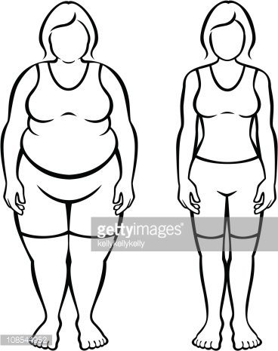

_ _ _ _ _ _ _ _ _ _ _ _ _ _ _ _ _ _ _ _ _ _ _ _ _ _ _ _ _ _ _ _ _ _ _ _ _ _ _ _

_ _ _ _ _ _ _ _ _ _ _ _ _ _ _ _ _ _ _ _ _ _ _ _ _ _ _ _ _ _ _ _ _ _ _ _ _ _ _ _

_ _ _ _ _ _ _ _ _ _ _ _ _ _ _ _ _ _ _ _ _ _ _ _ _ _ _ _ _ _ _ _ _ _ _ _ _ _ _ _

_ _ _ _ _ _ _ _ _ _ _ _ _ _ _ _ _ _ _ _ _ _ _ _ _ _ _ _ _ _ _ _ _ _ _ _ _ _ _ _

_ _ _ _ _ _ _ _ _ _ _ _ _ _ _ _ _ _ _ _ _ _ _ _ _ _ _ _ _ _ _ _ _ _ _ _ _ _ _ _

_ _ _ _ _ _ _ _ _ _ _ _ _ _ _ _ _ _ _ _ _ _ _ _ _ _ _ _ _ _ _ _ _ _ _ _ _ _ _ _ _ _ _ _ _ _ _ _ _ _

_ _ _ _ _ _ _ _ _ _ _ _ _ _ _ _ _ _ _ _ _ _ _ _ _ _ _ _ _ _ _ _ _ _ _ _ _ _ _ _ _ _ _ _ _ _ _ _ _ _

Quels sont les principaux savoir / savoir-faire et savoir-être, qu’un(e) Assistant(e) De Vie aux Familles doit posséder pour exercer ce métier ?

-- Savoir / savoir faire

- -

- -

- -

- -

- -

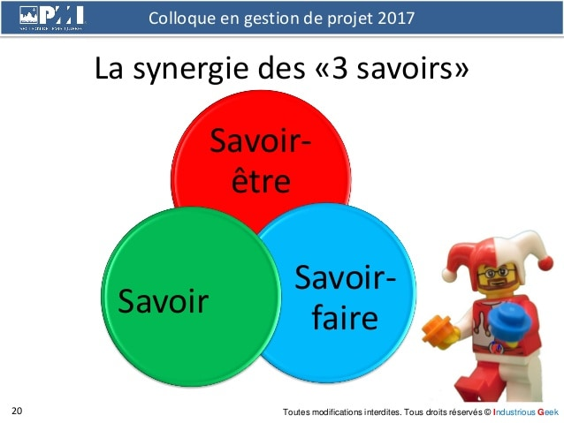

- Savoir - être

-

-

-

-

-

-

-

-

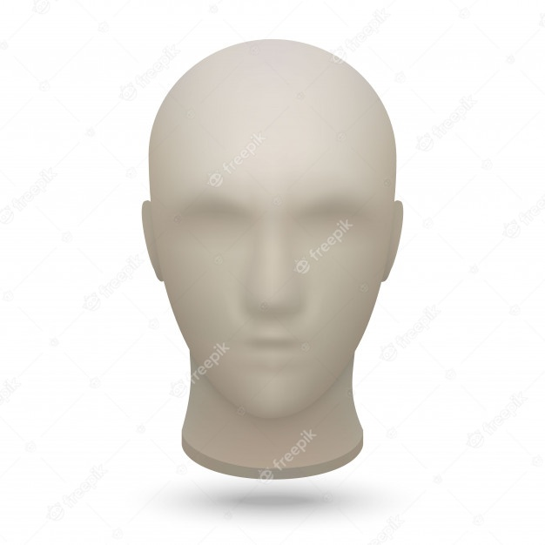Selon vous, qu’elle expression du visage devons-nous avoir auprès de la personne aidée ?

Aidez-vous d’un crayon de papier et dessinez le visage de l’ADVF que vous voulez être.

À quelles fréquences devez-vous réaliser les tâches suivantes ?

|  |  |  |  |  |  |
| --- | --- | --- | --- | --- | --- |
| TACHES | **Tous les jours** | **1 à 2 fois / semaine** | **Tous les 15 jours** | **Tous les mois** | **1 à 2 fois / an** |
| **Le micro-onde** |  |  |  |  |  |
| **Réfrigérateur** |  |  |  |  |  |
| **Réfection du lit** |  |  |  |  |  |
| **Nettoyer toutes les vitres** |  |  |  |  |  |
| **Nettoyer les moquettes avec un Shampooing** |  |  |  |  |  |
| **Enlever le calcaire dans la cuisine**  **et la salle de bain** |  |  |  |  |  |
| **Dépoussiérer les meubles** |  |  |  |  |  |
| **Faire la vaisselle** |  |  |  |  |  |

*

Citez deux actions à réaliser en fin d’intervention.

* _ _ _ _ _ _ _ _ _ _ _ _ _ _ _ _ _ _ _ _ _ _ _ _ _ _ _ _ _ _ _ _ _ _ _ _ _ _ _ _ _ _ _ _ _ _ _ _ _

_ _ _ _ _ _ _ _ _ _ _ _ _ _ _ _ _ _ _ _ _ _ _ _ _ _ _ _ _ _ _ _ _ _ _ _ _ _ _ _ _ _ _ _ _ _ _ _ _ _

* _ _ _ _ _ _ _ _ _ _ _ _ _ _ _ _ _ _ _ _ _ _ _ _ _ _ _ _ _ _ _ _ _ _ _ _ _ _ _ _ _ _ _ _ _ _ _ _ _

_ _ _ _ _ _ _ _ _ _ _ _ _ _ _ _ _ _ _ _ _ _ _ _ _ _ _ _ _ _ _ _ _ _ _ _ _ _ _ _ _ _ _ _ _ _ _ _ _ _ _

Avec les produits d’entretien suivant, quel est son utilité et quelle est son action recherchée ?

* Produit à vitre : _ _ _ _ _ _ _ _ _ _ _ _ _ _ _ _ _ _ _ _ _ _ _ _ _ _ _ _ _ _ _ _ _ _ _ _ _ _ _ _ _ _ _ _ _ _ _ _ _ _ _ _ _ _ _ _ _ _ _ _ _ _ _ _ _ _ _ _ _ _ _ _ _ _ _ _ _ _ _ _ _ _ _ _ _ _ _ _ _
* Le Bec verseur pour Toilette : _ _ _ _ _ _ _ _ _ _ _ _ _ _ _ _ _ _ _ _ _ _ _ _ _ _ _ _ _ _ _ _ _ _ _ _ _ _ _ _ _ _ _ _ _ _ _ _ _ _ _ _ _ _ _ _ _ _ _ _ _ _ _ _ _ _ _ _ _ _ _ _ _ _ _ _ _ _ _ _ _
* Produit pour ameublement donnant et recevant de l’eau : _ _ _ _ _ _ _ _ _ _ _ _ _ _ _ _ _ _ _ _ _ _ _ _ _ _ _ _ _ _ _ _ _ _ _ _ _ _ _ _ _ _ _ _ _ _ _ _ _ _ _ _ _ _ _ _ _ _ _ _ _ _ _ _ _ _ _ _ _ _ _ _ _ _ _ _ _ _ _ _ _ _ _ _ _ _ _ _ __ _ _ _ _ _ _ _ _ _ _ _ _ _ _ _ _ _ _ _ _ _ _ _ _ _ _ _
* Ameublement des WC de la Salle de Bain, cuisine etc… ils ont tous un produit en commun le quel ? _ _ _ _ _ _ _ _ _ _ _ _ _ _ _ _ _ _ _ _ _ _ _ _ _ _ _ _ _ _ _ _ _ _ _ _ _ _ _ _ _ _ _ _ _ _ _ _ _ _ _ _ _ _ _ _ _ _ _ _ _ _ _ _ _ _ _ _ _ _ _ _ _ _ _ _ _ _ _ _ _ _ _ _ _ _ _ _ _ _ _ _ _
* Chaise percé, lit, matelas à langer, bassine etc… ils ont tous le même produit le quel ?_ _ _ _ _ _ _ _ _ _ _ _ _ _ _ _ _ _ _ _ _ _ _ _ _ _ _ _ _ _ _ _ _ _ _ _ _ _ _ _ _ _ _ _ _ _ _ _ _ _ _ _ _
* Table de cuisson, gazinière, plat etc… ils ont tous le même produit le quel ?_ _ _ _ _ _ _ _ _ _ _ _ _ _ _ _ _ _ _ _ _ _ _ _ _ _ _ _ _ _ _ _ _ _ _ _ _ _ _ _ _ _ _ _ _ _ _ _ _ _ _ _ _ _ _ _ _ _ _

Quelles sont les précautions que vous devez prendre lors de l’utilisation des produits ménagers ?

* _ _ _ _ _ _ _ _ _ _ _ _ _ _ _ _ _ _ _ _ _ _ _ _ _ _ _ _ _ _ _ _ _ _ _ _ _ _ _ _ _ _ _ _ _ _ _ _ _
* _ _ _ _ _ _ _ _ _ _ _ _ _ _ _ _ _ _ _ _ _ _ _ _ _ _ _ _ _ _ _ _ _ _ _ _ _ _ _ _ _ _ _ _ _ _ _ _ _
* _ _ _ _ _ _ _ _ _ _ _ _ _ _ _ _ _ _ _ _ _ _ _ _ _ _ _ _ _ _ _ _ _ _ _ _ _ _ _ _ _ _ _ _ _ _ _ _ _
* _ _ _ _ _ _ _ _ _ _ _ _ _ _ _ _ _ _ _ _ _ _ _ _ _ _ _ _ _ _ _ _ _ _ _ _ _ _ _ _ _ _ _ _ _ _ _ _ _
* _ _ _ _ _ _ _ _ _ _ _ _ _ _ _ _ _ _ _ _ _ _ _ _ _ _ _ _ _ _ _ _ _ _ _ _ _ _ _ _ _ _ _ _ _ _ _ _ _
* _ _ _ _ _ _ _ _ _ _ _ _ _ _ _ _ _ _ _ _ _ _ _ _ _ _ _ _ _ _ _ _ _ _ _ _ _ _ _ _ _ _ _ _ _ _ _ _ _

Quelles sont les deux pièces de la maison, où il y a beaucoup de micro-organismes ?

* _ _ _ _ _ _ _ _ _ _ _ _ _ _ _ _ _ _ _ _ _ _ _ _ _ _ _ _ _ _ _ _ _ _ _ _ _ _ _ _ _ _ _ _ _ _ _ _ _
* _ _ _ _ _ _ _ _ _ _ _ _ _ _ _ _ _ _ _ _ _ _ _ _ _ _ _ _ _ _ _ _ _ _ _ _ _ _ _ _ _ _ _ _ _ _ _ _ _

Ouvrir les fenêtres permet ?

* _ _ _ _ _ _ _ _ _ _ _ _ _ _ _ _ _ _ _ _ _ _ _ _ _ _ _ _ _ _ _ _ _ _ _ _ _ _ _ _ _ _ _ _ _ _ _ _ _
* _ _ _ _ _ _ _ _ _ _ _ _ _ _ _ _ _ _ _ _ _ _ _ _ _ _ _ _ _ _ _ _ _ _ _ _ _ _ _ _ _ _ _ _ _ _ _ _ _
* _ _ _ _ _ _ _ _ _ _ _ _ _ _ _ _ _ _ _ _ _ _ _ _ _ _ _ _ _ _ _ _ _ _ _ _ _ _ _ _ _ _ _ _ _ _ _ _ _
* _ _ _ _ _ _ _ _ _ _ _ _ _ _ _ _ _ _ _ _ _ _ _ _ _ _ _ _ _ _ _ _ _ _ _ _ _ _ _ _ _ _ _ _ _ _ _ _ _

À quels risques devez-vous faire attention lorsque vous aérer les pièces ?

* _ _ _ _ _ _ _ _ _ _ _ _ _ _ _ _ _ _ _ _ _ _ _ _ _ _ _ _ _ _ _ _ _ _ _ _ _ _ _ _ _ _ _ _ _ _ _ _ _
* _ _ _ _ _ _ _ _ _ _ _ _ _ _ _ _ _ _ _ _ _ _ _ _ _ _ _ _ _ _ _ _ _ _ _ _ _ _ _ _ _ _ _ _ _ _ _ _ _
* _ _ _ _ _ _ _ _ _ _ _ _ _ _ _ _ _ _ _ _ _ _ _ _ _ _ _ _ _ _ _ _ _ _ _ _ _ _ _ _ _ _ _ _ _ _ _ _ _
* _ _ _ _ _ _ _ _ _ _ _ _ _ _ _ _ _ _ _ _ _ _ _ _ _ _ _ _ _ _ _ _ _ _ _ _ _ _ _ _ _ _ _ _ _ _ _ _ _
* _ _ _ _ _ _ _ _ _ _ _ _ _ _ _ _ _ _ _ _ _ _ _ _ _ _ _ _ _ _ _ _ _ _ _ _ _ _ _ _ _ _ _ _ _ _ _ _ _
* _ _ _ _ _ _ _ _ _ _ _ _ _ _ _ _ _ _ _ _ _ _ _ _ _ _ _ _ _ _ _ _ _ _ _ _ _ _ _ _ _ _ _ _ _ _ _ _ _
* _ _ _ _ _ _ _ _ _ _ _ _ _ _ _ _ _ _ _ _ _ _ _ _ _ _ _ _ _ _ _ _ _ _ _ _ _ _ _ _ _ _ _ _ _ _ _ _ _

